**REFERENCES FOR LAST PROJECT(LAFORANT)**

Group Members:

1. Clement Tanudjaja - 2440005095
2. Francesco Jovan - 2440007762
3. Ryan Wibawa - 2440013834

Class: BR01 - Lab

The logo is created by our group.

**Website used as Reference:**

1. <https://playvalorant.com/en-us/>
2. <https://www.dafont.com/search.php?q=valorant> (Font used in our website)

**Reference Images Used in Our Website:**

1. <https://i.pinimg.com/originals/de/1c/91/de1c91788be0d791135736995109272a.png> (The Youtube logo used in footer, file name: logo yt.png)
2. <https://cdn.iconscout.com/icon/free/png-256/facebook-logo-2019-1597680-1350125.png> (The Facebook logo used in footer, file name: logo fb.png)



1. <https://download.logo.wine/logo/Instagram/Instagram-Logo.wine.png> (The Instagram logo used in footer, file name: logo ig.png)
2. <https://playvalorant.com/en-us/media/all/agents> (Preview Agents wallpaper used in Homepage, file name: preview-agents.jpg)

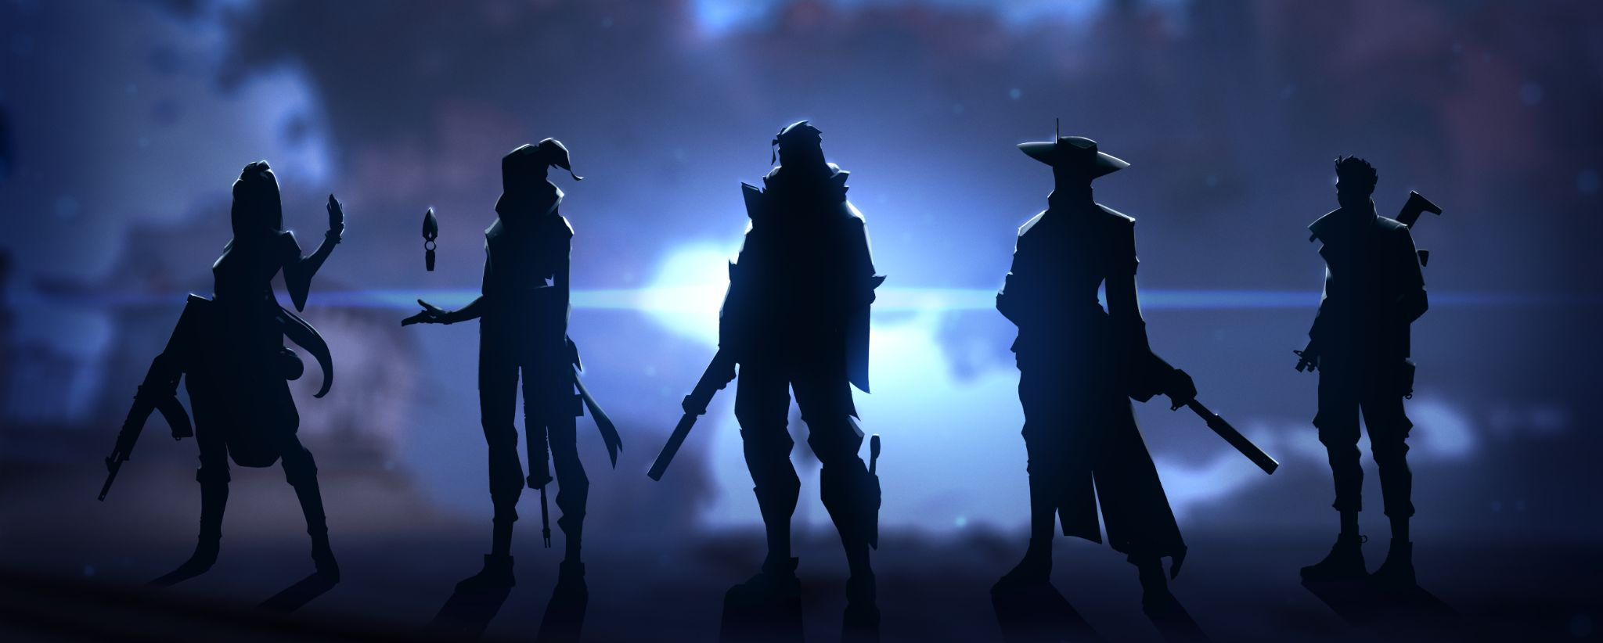

1. <https://playvalorant.com/en-us/media/all/maps> (Preview Maps wallpaper used in Homepage, file name: map.jpg)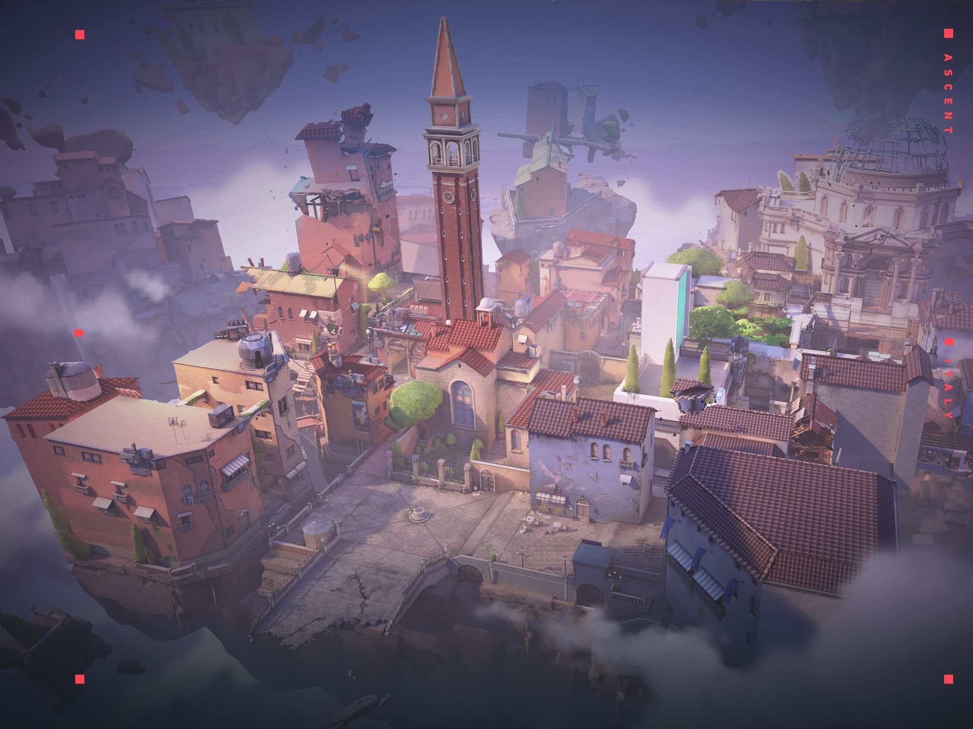
2. <https://playvalorant.com/en-us/media/artwork> ( Preview Spec Requirements wallpaper used in Spec Require page, file name :specwall.jpg)

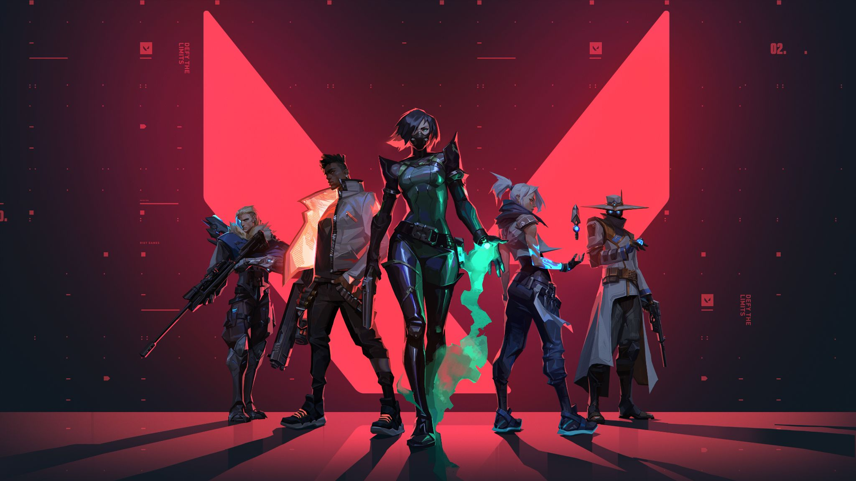

1. [https://playvalorant.com](https://playvalorant.com/en-us/media/artwork) (Used in Maps page and Agents page)

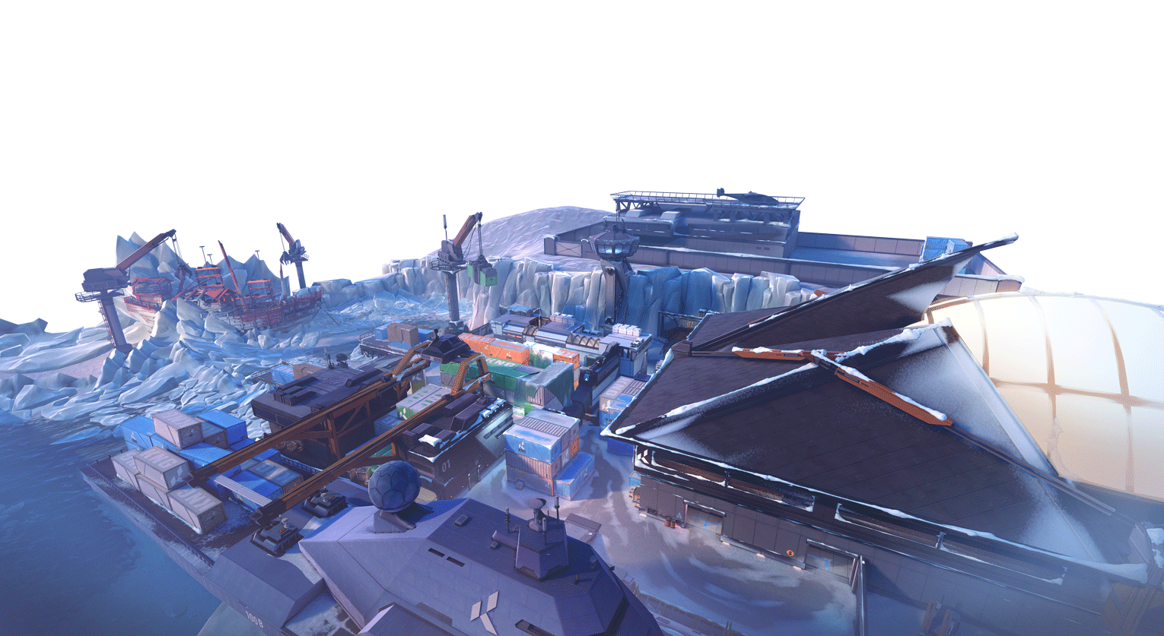

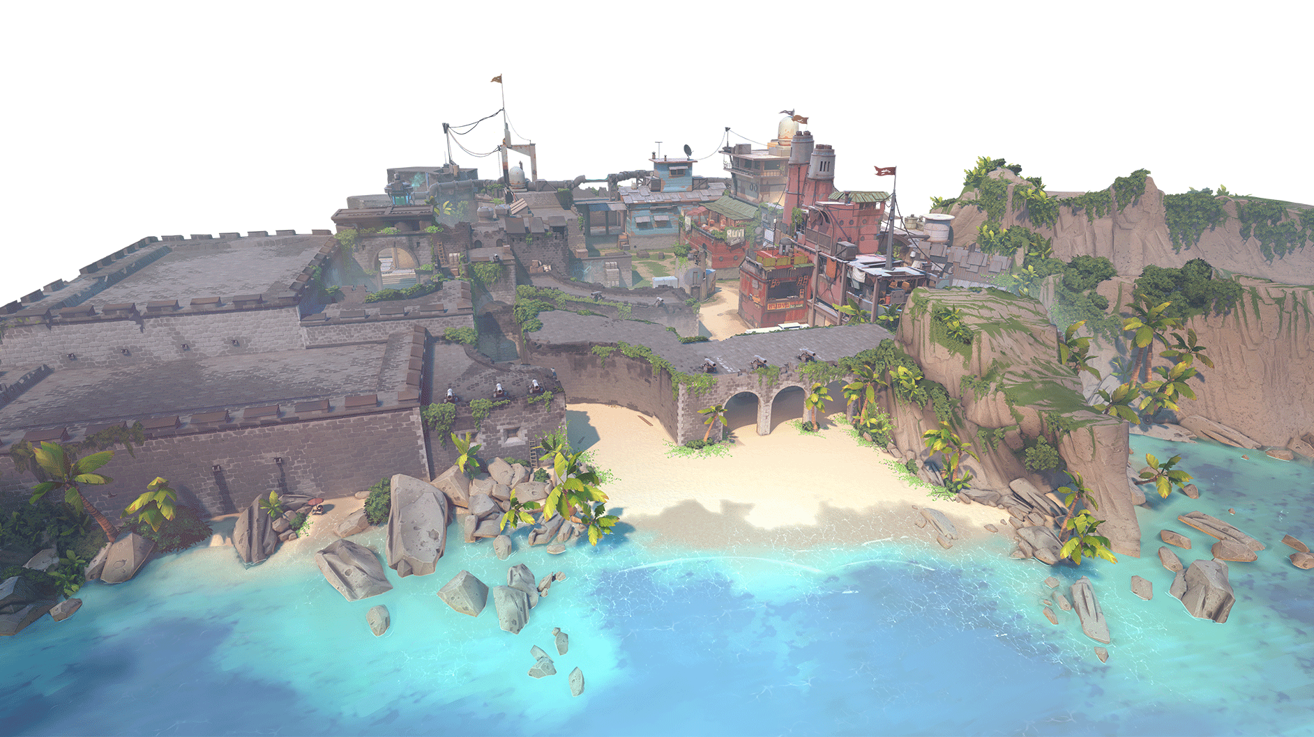

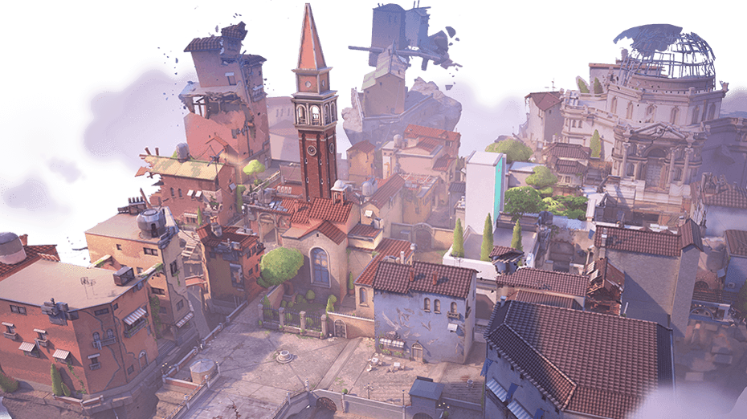

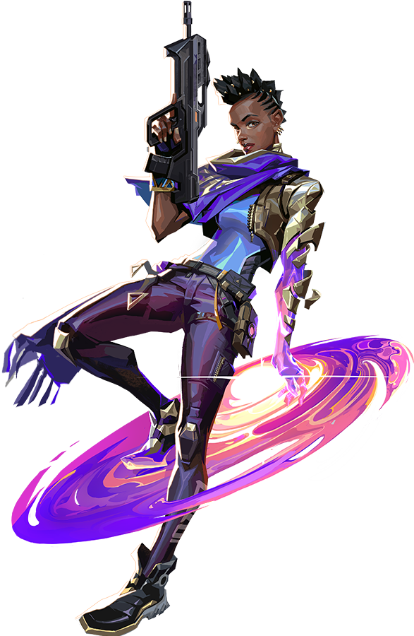

1. 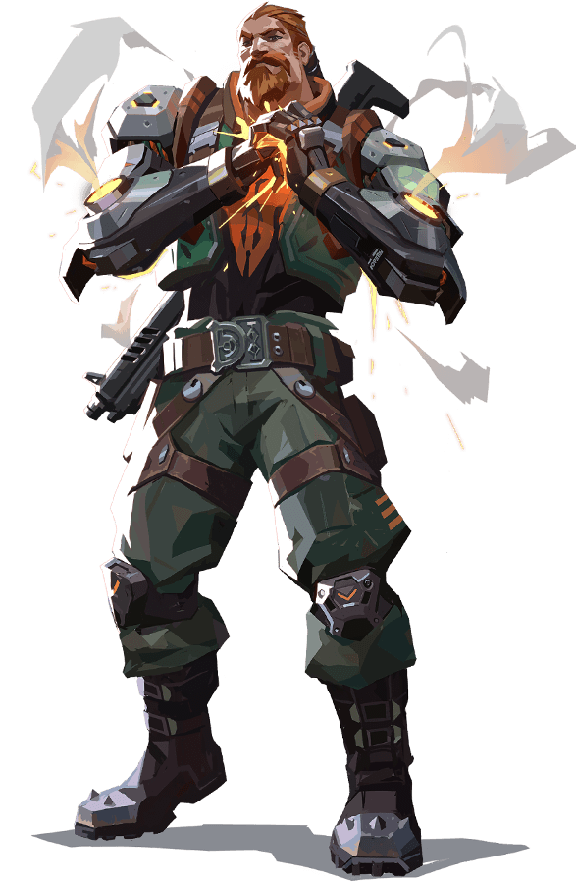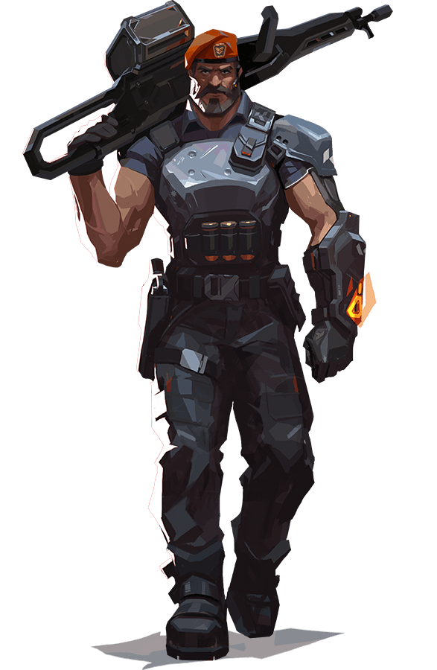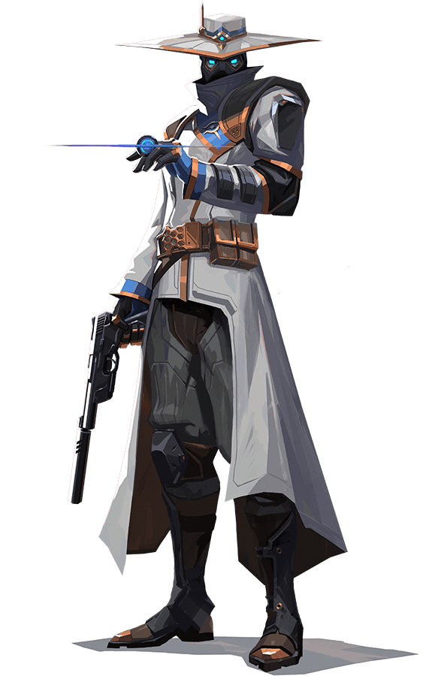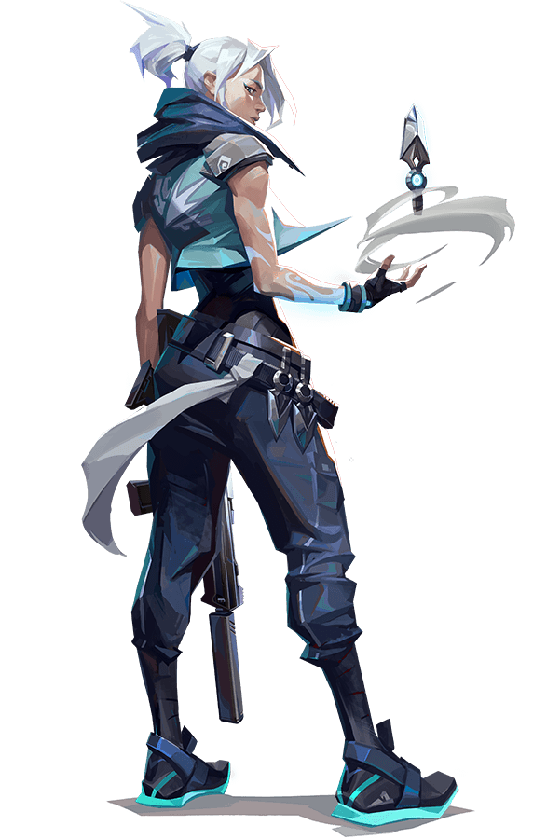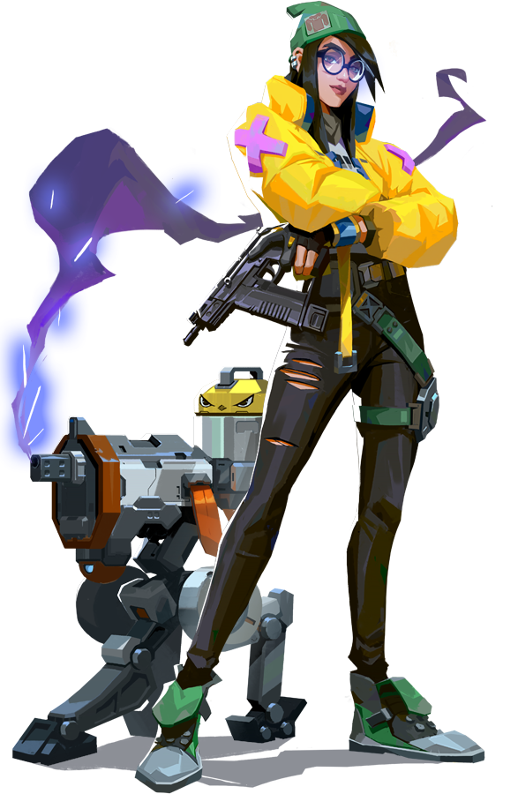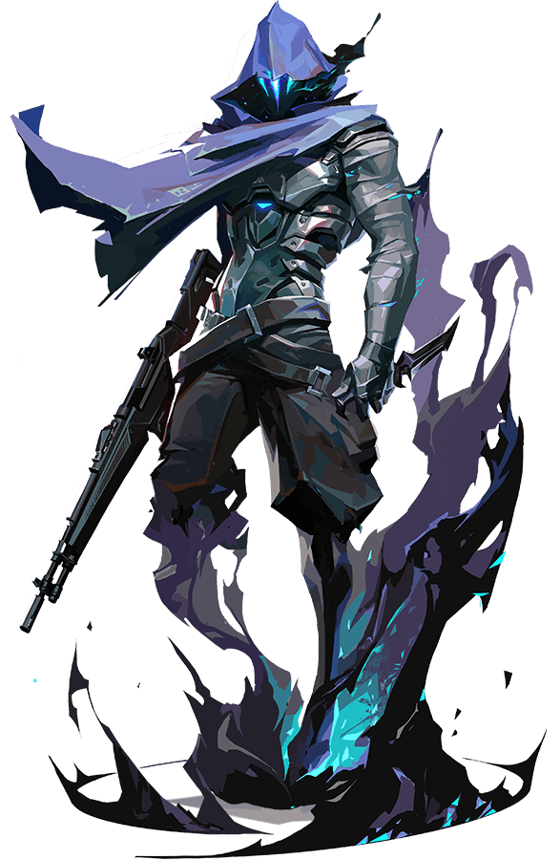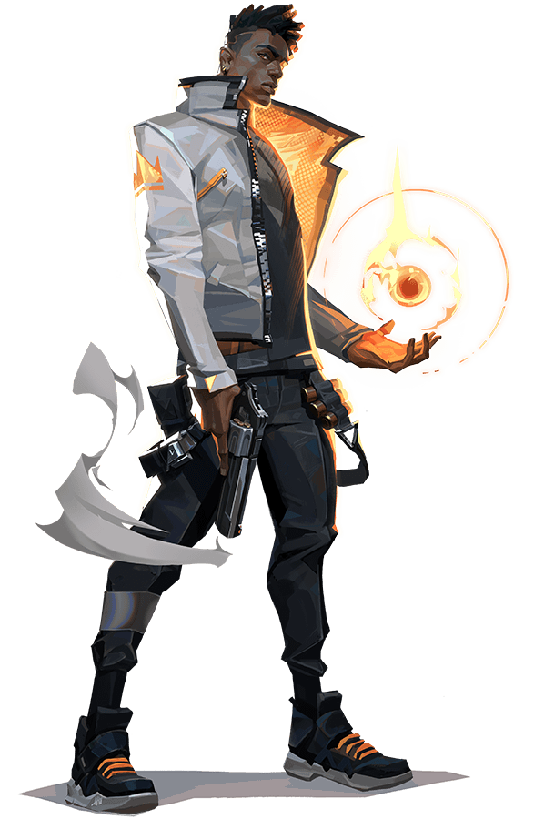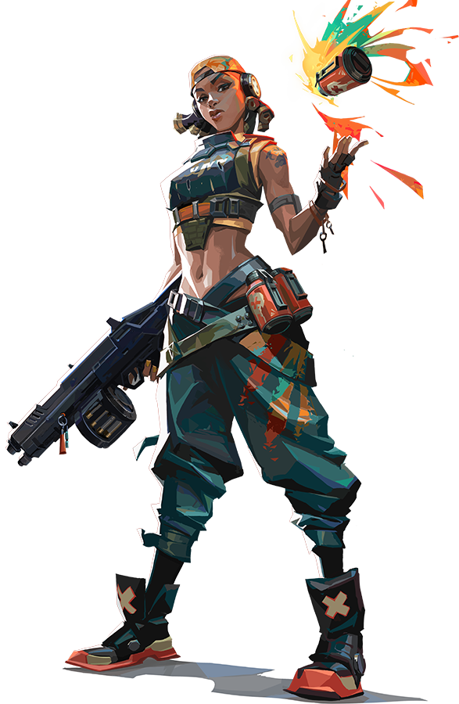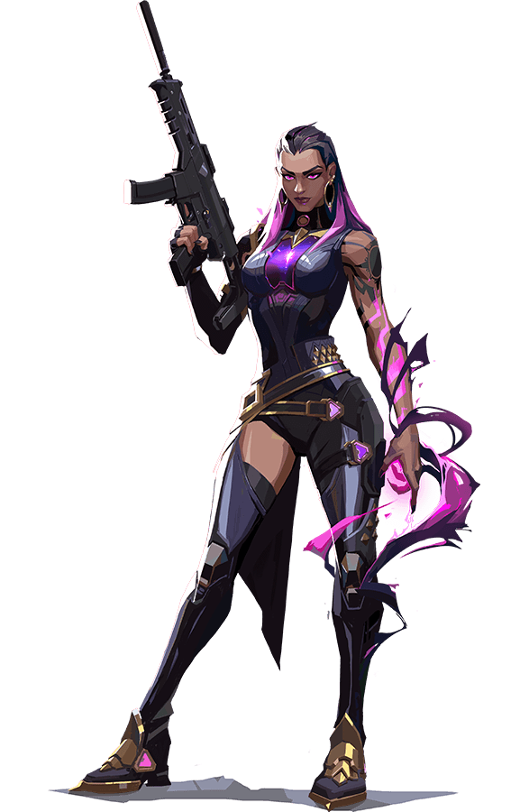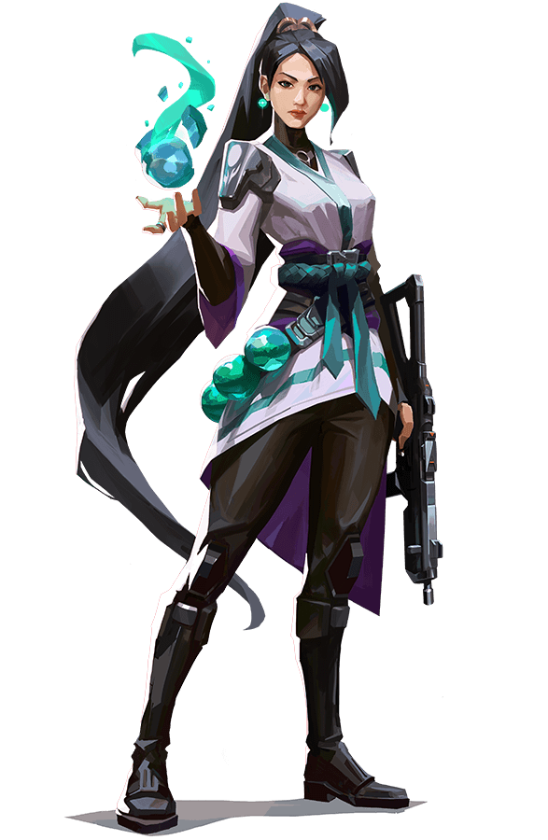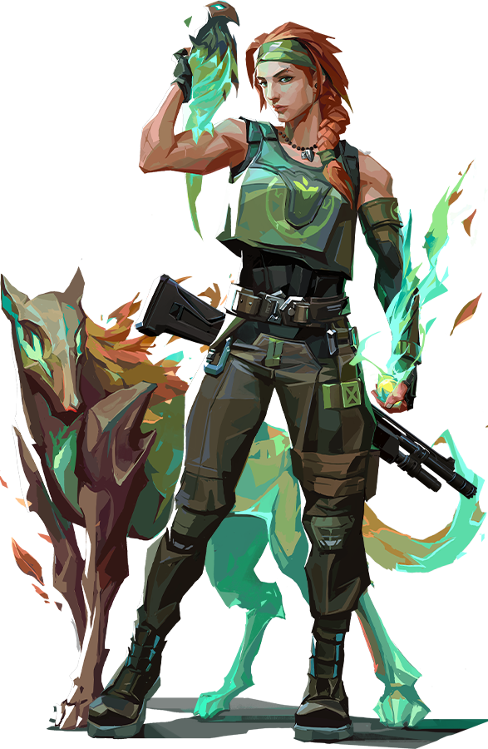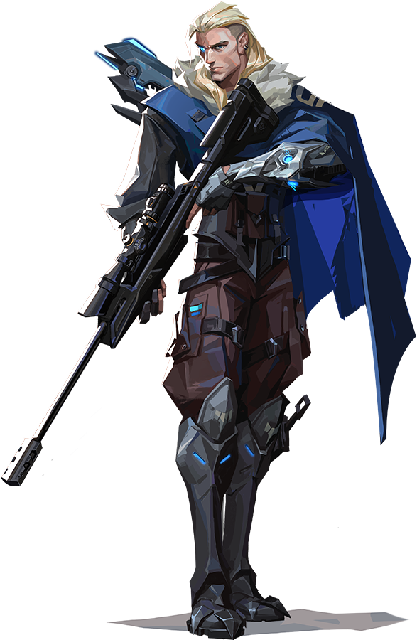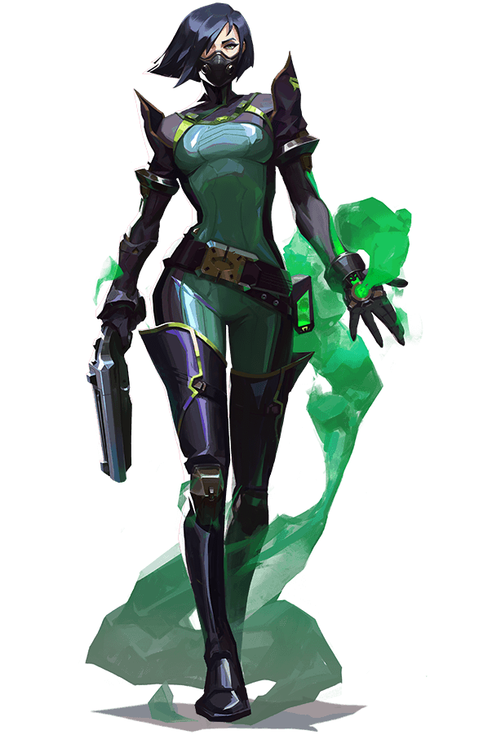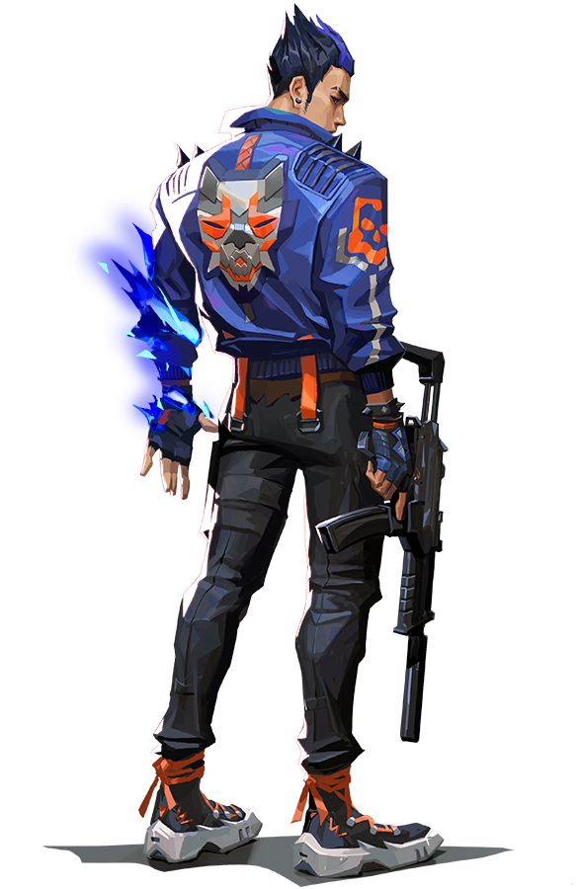



8.<https://assets.contentstack.io/v3/assets/bltb6530b271fddd0b1/blt29d7c4f6bc077e9e/5eb26f54402b8b4d13a56656/agent-background-generic.mp4> -> link video for agents page from valorant web.

1. <https://www.canva.com/> (One of the icon used in our web from canva’s element)

